***This file provides the guide for the game HANGMAN.***

* ***Select the option of your interest and this window will pop up:***

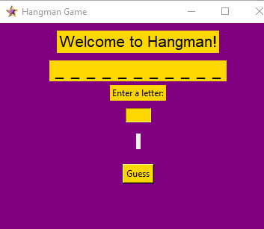

* ***There is an entry box under the label ENTER A LETTER.***
* ***After entering the letter click on press that will display a label which states whether it is a correct guess or not.***